DIY Detectors
Instruction Manual 2026
by Zeke Young
Table of Contents
Brief Introduction to the Activity (for hosts/facilitators) 2
Parts and Pieces 3
Running the Activity 5
After the Activity (Assessment) 8
Possible Extensions of the Activity 10
Further Reading 11

Brief Introduction to the Activity (for hosts/facilitators)
DIY Detectors is a particle and nuclear physics (PNP) outreach activity that is based on the enquiry-based approach to learning (EBL). EBL is an approach that emphasizes allowing participants to develop skills and interest in subjects in ways that resemble scientific research (Rude 2024). It focuses on student directed, enquiry driven activities, which allows participants to feel more involved, and thus more motivated to learn (Kahn and O’Rourke 2004).
In DIY Detectors, participants are asked to build their own detectors out of PVC pipes and 3D printed connectors/junctions, to try to determine the qualities of several unknown “particles” (marbles) that will be sent through them. The goal of the activity is that participants will model, construct, and test different iterations of detectors with different setups, attempting to find the detector set up that will allow them to make the most accurate measurement of how many of each type of marble went through their detector.
This activity is intended to take 45 minutes to an hour, and is targeted towards individuals or small groups (2-3 people) that have had limited physics education (i.e. may have had a physics class or two in high school or university, but didn’t study physics as a major and does not work in or research physics in the present day). People who have more in depth PNP knowledge may enjoy this activity as well, but will probably not gain any new knowledge from it.
In this instruction manual, you will find a list of the physical parts of the activity, instructions on how to run the activity, suggestions for how to assess the activity’s impacts on participants, and resources to look more in depth at the theory behind the activity’s construction.
For more documentation, information, and access to things like the example presentation and the provided code, please go to: https://github.com/zmyoung03/Detector-Design-Outreach-Activity/tree/main.

Parts and Pieces
- ~10 cm PVC pipe sections
- Plain 3D printed tube connectors
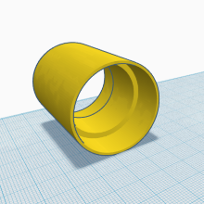

- Basket 3D printed tube connectors
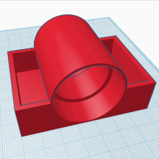
- Hollow basket 3D printed tube connectors
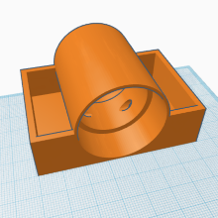
- Clips with baskets
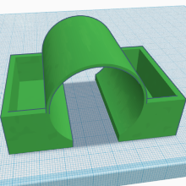
- Wye junctions
- Wye junctions with interior barriers
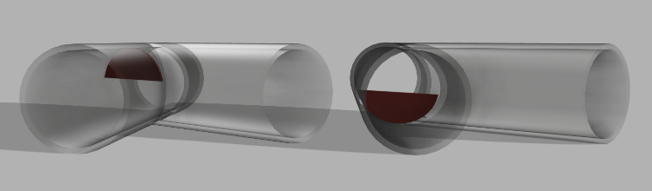
- Wye junctions with baskets
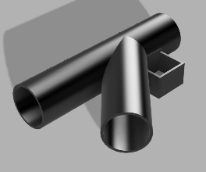
- Magnets
- Non-magnetic counterweights
- Break-beam IR motion sensors
- Breadboards
- Mail-female 22 AWG single-stranded copper wires (to connect the microcontrollers to breadboards)
- Marbles
  - Of two different sizes
  - Some magnetic, some non-magnetic, preferably all opaque
- Raspberry Pi’s or some other microcontrollers
- Python3 on whatever microcontrollers you decide to use, if you’d like to use the provided code
- LEGOs to use for detector support
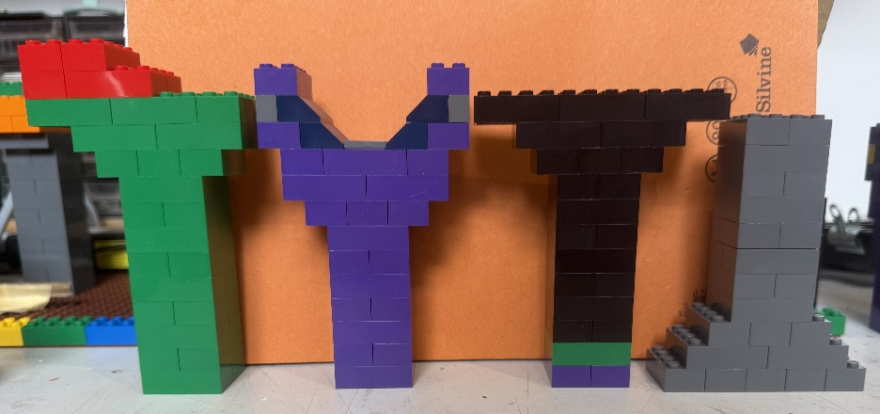

Running the Activity
As stated above, the purpose of this activity is to have participants create their own detectors, which they then use to determine the type and amount of different ‘particles or marbles.
A general timeline for the activity is as follows:
- Activity worksheets are passed out to the participants
- The host (you) gives a presentation introducing the participants to the activity and themselves
  - The presentation should cover
    - the basic, overarching concepts behind the activity (i.e. what is particle physics, what are particle detectors/accelerators and how do they work)
    - some of the different parts they’ll be using (the different junctions, tubing, and marble types, as well as the magnets, and the BBIR sensors + whatever coding system is being used)
    - some helpful tips (i.e. looking inside the pipe junctions to see if they have barriers in them or not and noting that different orientations may have different barriers/paths)
  - At the end of the presentation, a challenge will be issued: at the end of the activity, a number of unknown particles will be sent down each participant’s (or participant group’s) detector. They will use their detector to determine how many of each type of marble was sent through, and report that number to the large group. The host can then tell them how accurate their measurement was
    - The unknown marble selection (or multiple unknown marble selections, if there are multiple groups) can be created before or during the session. What’s important is that the host knows the amount and types of the marbles in the selection, but the participants do not. Participants should not be allowed to see the marbles in the selection if at all possible
  - Please see the example slides on the linked github for more details
- Although all participants will be using the same materials for their detectors, the setup of the detectors themselves are very variable. Participants can change
- The angle the detector is at
- The amount of splits in the detector
- How long the detector is
- Where the splits and sensors are in the detector
- The design and location of the supports for the detector
- And more!
So, as the participants create their detectors:
  - They will determine how and in what order they want to separate the different types of particles in the detector (do they separate non magnetic from magnetic first, or do they separate by size, and then by magnetism?)
  - They can model their detectors by drawing their designs out on the worksheets, indicating where each split will be, and where their counting sensors will be. This step can help save time by allowing them to ‘rearrange’ their detector on paper instead of physically building and disassembling it repeatedly
  - They will build their detectors based on their models, including their counting sensors
  - They’ll connect their counting sensors to a computer, and code a simple program that will count each time a sensor is tripped individually
    - This can also be a premade program, provided on the github page linked above
  - They’ll test their detectors using known amounts of different marble types.
    - If it works the first time, wonderful!
    - If it doesn’t work, they can troubleshoot their detector, using both it, and their models. Once they’ve identified the issue they can redo their models and detectors, and try again until they are satisfied with how their detector works
- Once all participants/participant groups are satisfied with their detectors, or at around 10-15 minutes before the end of the session, the host should go around the room and send the unknown marbles through each detector.
  - If the same selection of marbles is being sent down every detector, don’t have participants announce their findings until after all detectors have been tested. If different selections are being used, findings can be declared and told if they’re correct or not after each detector test
- After all detectors have been tested and told whether their findings are correct, the host should end the session with another short presentation
  - The presentation should reiterate the basic concepts the activity was based on and bring what the participants learned back to particle physics
  - You could also use examples of real world accelerators/detectors and make parallels with the detectors/accelerators that participants made
    - i.e. circular vs linear accelerators, counting detectors, magnet use in detectors/accelerators, etc
  - Please see the example slides on the linked github for more details.

Problems Participants May Come Across:
The magnets aren’t working! They won’t pull the magnetic particles to the side!
Check:
- Are the magnets angled at all? Changing the angle so it lines up more with the path, or moving the magnet to a different spot in its holder may help
- Is there a barrier in the junction that’s blocking marbles?
- Is one of the legs of the junction lower than the other? This will cause marbles to go down that one instead
- Are the marbles going through the magnet’s range of influence too quickly? Try adding more magnets (using more magnet holders), or reducing the slope of the detector path

The barriers aren’t working! Large and small marbles are going down the same path!
Check:
- Is there actually a barrier in the wye? Is the barrier on the top or the bottom of the junction?
- Is one of the legs of the junction lower than the other? This will cause marbles to go down that one instead

The IRBB sensors aren’t working! What’s going on?
Check:
- Are all connections still in place?
- Are all the sensors connected to the right pins (the ones in the code)?
- Are the sensors lined up to the holes in the holders, so the beam can actually go through?
- Will the sensors trip if something other than a marble passes through the beam?

After the Activity (Assessment)
My suggestion for getting feedback on the activity, based on Ogden Trust and Queen Mary University of London’s evaluation toolkits is creating short questionnaires to be given to participants (at minimum) after the activity. Questions can be answered using short answers, multiple choice responses, and scaled/ranking responses. If possible, having before and after questionnaires may be beneficial depending on what information one is looking for.
You should tailor your questions to your anticipated demographic. The questions I asked my prototype testers, who were MSCi PNP students, are different from the questions I wrote for secondary school aged or adult non-Physicists. There are some questions in the example slideshow for the whole group to answer. Here are some potential questions, or lines of questioning, that you may find helpful to ask participants individually:
Learning outcomes
- In your own words, what was this activity trying to teach you about particle/nuclear physics?
- Is there anything you understand differently now than before you started?
- If a friend who'd never done this activity asked you to explain what a detector does, what would you tell them?
  - Could you draw me/them a picture of a particle detector?
  - Could you tell me one new fact about PNP you learned today?
- On a scale of 1 to 5, how much do you know about (particle) physics?
Engagement/enjoyment
- What part of this did you find most interesting or fun? What part dragged?
- Did you feel like you were "figuring something out," or more like following a recipe?
- Was there a moment you got curious about something beyond what the activity asked?
  - (What) Did you want to explore further?
- On a scale of 1 to 5, how fun do you think (particle) physics is?
General / wrap-up
- If you could change one thing about this activity, what would it be?
- Was the difficulty about right for someone with your level of physics background, or too easy/too hard?
- Would you want to do something like this again, or recommend it to someone else?

Possible Extensions of the Activity
If you would like to extend the activity by adding different types of detectors and marbles, you can! Here are some potential extensions of the activity:
- You could create ice marbles of similar sizes to the marbles you already have and send them down the detector and use hydrochromic paper to track them. Depending on the length of the detector and the temperature of their surroundings, they may or may not fully melt before the end. How does this affect how participants count particles?
- You could heat up some marbles using a hot plate and a container of water, and use thermochromic paper to track them. Depending on the length of the detector and the temperature of their surroundings, they may or may not fully cool before the end. How does this affect how participants count particles?
  - Both of these examples add a new convolution to the detector setup. How do you tell the other properties of the heated or ice marbles? Do you test for temperature/moisture at the end of the detector, right before the counters, and risk not having the temperature/moisture to be detected, or do you test at the beginning of the detector, with no way to know what size/magnetic quality the new marbles have?

Further Reading
If you would like to read more about EBL, scientific modelling, or other EBL-based PNP activities, please see the sources below!
“Lab workshops.” https://sciencegateway.cern/lab.
B. Thacker, Inquiry-based experimental physics: Twenty years of an evidence-based, laboratory-based physics course for algebra-based physics students, Phys. Rev. Phys. Educ. Res. 19 (2023) .
D. C. Edelson, D. N. Gordin and R. D. Pea, Addressing the Challenges of Inquiry-Based Learning through Technology and Curriculum Design, The Journal of the Learning Sciences 8 (1999) 391.
K. Borner, K. Boyack, S. Milojevic and S. Morris, An Introduction to Modeling Science: Basic Model Types, Key Definitions, and a General Framework for the Comparison of Process Models. 01, 2012. 10.1007/978-3-642-23068-41.
L. Rude, Inquiry-Based Learning, pp. 727–728. 01, 2025. 10.1007/978-981-97-7874-41098.
M. G. Bardeen, O. M. Bitter, M. Glover, S. J. de Jong, T. R. Lewis, M. Fetsko et al., Particle physics outreach to k-12 schools and opportunities in undergraduate education, 2022.
M. S. Bolger, J. B. Osness, J. S. Gouvea and A. C. Cooper, Supporting Scientific Practice through Model-Based Inquiry: A Students’-Eye View of Grappling with Data, Uncertainty, and Community in a Laboratory Experience, CBE Life Sciences Education 20 (2021) ar59.
P. Kahn and K. O’Rourke, UNDERSTANDING ENQUIRY-BASED LEARNING, Handbook of enquiry & problem based learning 2 (2005) .
P. Thill, J. Woithe and S. Schmeling, New educational activity about CMS air pads for education labs at CERN Science Gateway, p. 383, 11, 2022, DOI.

